

Model-Driven Conceptual Design

System Design and Management School

西村研究室

CNC project

Author: Kiet Foeken

Revision: 6.0

|  |  |
| --- | --- |
|  |  |
|  | Date: November 05, 2022 |

# Model Introduction

**Model** **Specification>Documentation**

Author:Kiet Foeken.

Created:4/17/17 4:29 PM.

Title:CNC Machine Model.

Comment: This document lines out the model of a modern 3-axis CNC machine. The model adds modernized components to the conventional CNC machine, whilst prioritizing the safety of the user and all bystanders while the machine is in use. Using feed forward and feedback models, the machine aims a sub-millimeter precision.

# All Project Diagrams

## CNC Machine

**Diagram Specification>Documentation**

**In:** Concept Model.CNC Machine

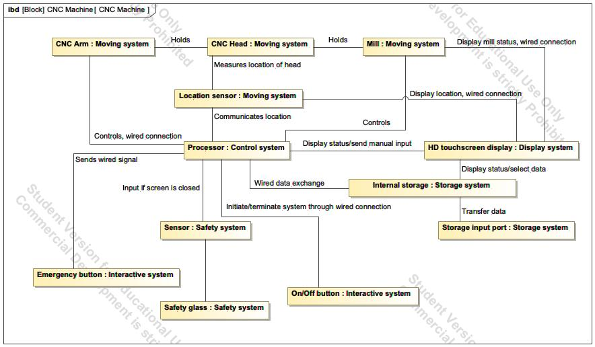

1. Diagram CNC Machine

## Mapping Concept to PoC

**Diagram Specification>Documentation**

**In:** Proof of Concepts.Mapping Concept to PoC

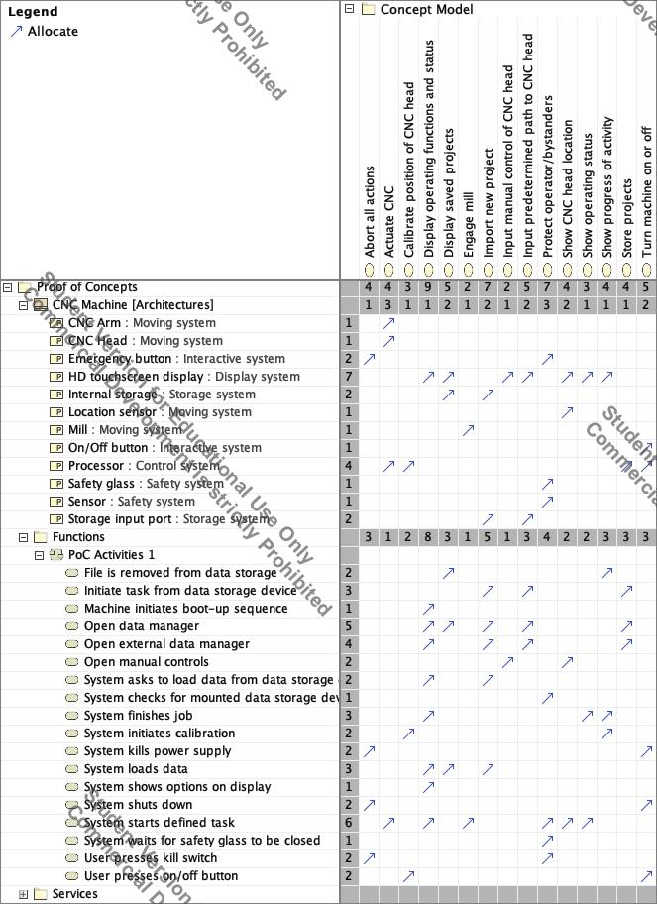

1. Diagram Mapping Concept to PoC

## PoC Activities 1

**Diagram Specification>Documentation**

**In:** Proof of Concepts.Functions.PoC Activities 1.PoC Activities 1

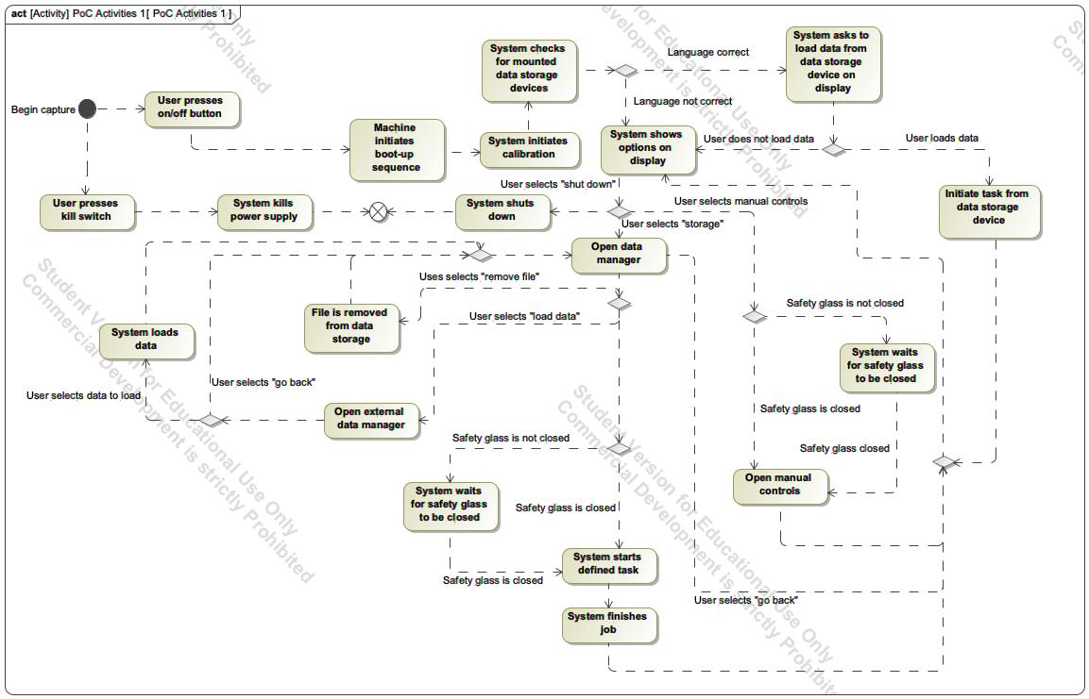

1. Diagram PoC Activities 1

## Concept Model

**Diagram Specification>Documentation**

**In:** Concept Model.Concept Model

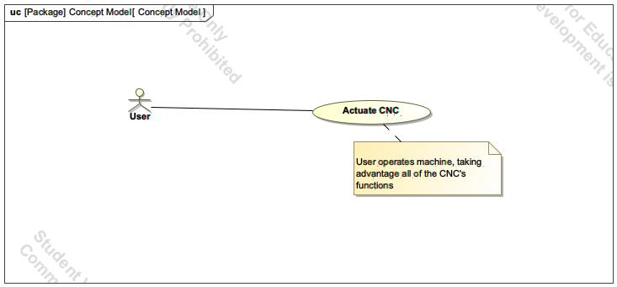

1. Diagram Concept Model

## PoC Model 1

**Diagram Specification>Documentation**

**In:** Proof of Concepts.PoC Model 1

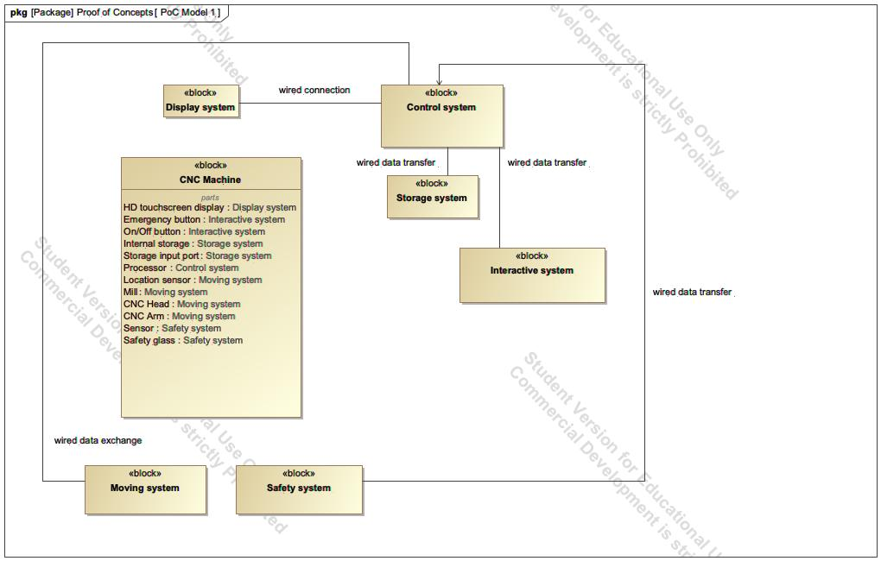

1. Diagram PoC Model 1

## PoC Blocks

**Diagram Specification>Documentation**

**In:** Concept Model.PoC Blocks

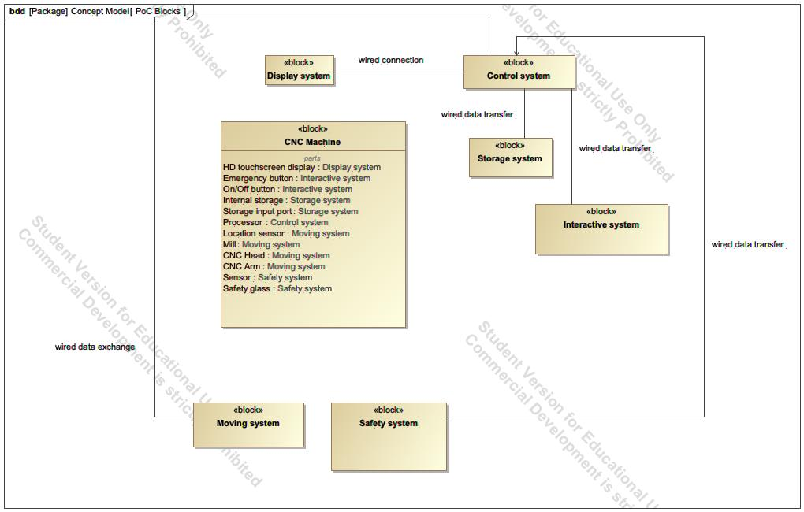

1. Diagram PoC Blocks

## PoC Use Case

**Diagram Specification>Documentation**

**In:** Proof of Concepts.Functions.PoC Use Case

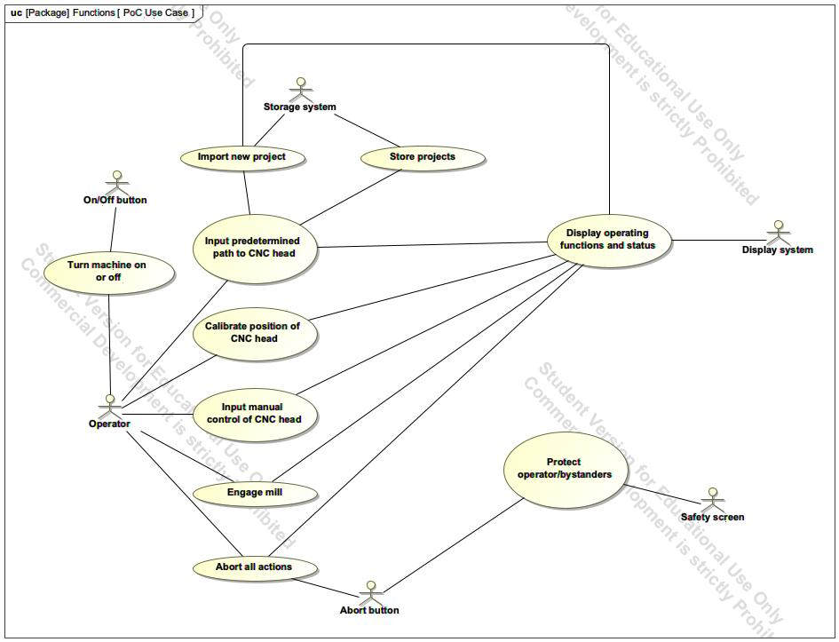

1. Diagram PoC Use Case

# Concept Use-Cases

|  |
| --- |
| **UseCase** |
| Abort all actions |
| Actuate CNC |
| Calibrate position of CNC head |
| Display operating functions and status |
| Engage mill |
| Import new project |
| Input manual control of CNC head |
| Input predetermined path to CNC head |
| Protect operator/bystanders |
| Store projects |
| Turn machine on or off |

## Actor Summary

|  |  |
| --- | --- |
| **Primary Actor** | **Use Cases** |
| Abort button | * Abort all actions      * Protect operator/bystanders |
| Display system | * Display operating functions and status      * Display saved projects      * Show CNC head location      * Show operating status      * Show progress of activity |
| On/Off button | * Turn machine on or off |
| Operator | * Abort all actions      * Calibrate position of CNC head      * Engage mill      * Input manual control of CNC head      * Input predetermined path to CNC head      * Turn machine on or off |
| Safety screen | * Protect operator/bystanders |
| Storage system | * Import new project      * Store projects |
| User | * Actuate CNC |

## Use Case: Concept Model Diagram



## Actuate CNC Use Case

|  |  |  |  |
| --- | --- | --- | --- |
| **Use Case Name** | Actuate CNC | ID |  |
| **Complexity** | Average Complexity | | |
| **Description** |  | | |
| **Actors** | * User | | |
| **Goal** |  | | |
| **Assumption** | No assumption for this use case. | | |
| **Non Functional Requirements** | No non-functional requirement for this use case. | | |

|  |  |
| --- | --- |
| **Relations** | |
| **Association** | * User Actor |
| **Generalization** |  |

## Use Case: PoC Use Case Diagram



## Abort all actions Use Case

|  |  |  |  |
| --- | --- | --- | --- |
| **Use Case Name** | Abort all actions | ID |  |
| **Complexity** | Average Complexity | | |
| **Description** | This function of aborting all actions is to be implemented as a security feature. In the case anything dangerous is going on or in the case of any failure, the user must be able to instantly kill the power to the CNC machine. | | |
| **Actors** | * Abort button * Operator | | |
| **Goal** |  | | |
| **Assumption** | No assumption for this use case. | | |
| **Non Functional Requirements** | No non-functional requirement for this use case. | | |

|  |  |
| --- | --- |
| **Relations** | |
| **Association** | * Abort button Actor * Display operating functions and status UseCase * Operator Actor |
| **Generalization** |  |

## Calibrate position of CNC head Use Case

|  |  |  |  |
| --- | --- | --- | --- |
| **Use Case Name** | Calibrate position of CNC head | ID |  |
| **Complexity** | Average Complexity | | |
| **Description** | The CNC machine has to be as accurate as possible. The atmospherical circumstances around the CNC machine might change, resulting int the machine to expand or shirk ever so slightly, leaving the machine inaccurate. Therefore, the machine should be calibrated before using. | | |
| **Actors** | * Operator | | |
| **Goal** |  | | |
| **Assumption** | No assumption for this use case. | | |
| **Non Functional Requirements** | No non-functional requirement for this use case. | | |

|  |  |
| --- | --- |
| **Relations** | |
| **Association** | * Display operating functions and status UseCase * Operator Actor |
| **Generalization** |  |

## Display operating functions and status Use Case

|  |  |  |  |
| --- | --- | --- | --- |
| **Use Case Name** | Display operating functions and status | ID |  |
| **Complexity** | Average Complexity | | |
| **Description** | The idea is to have one central place on the machine that shows an interface that incorporates the functions of the CNC machine and also shows status updates of the machine. | | |
| **Actors** | * Display system | | |
| **Goal** |  | | |
| **Assumption** | No assumption for this use case. | | |
| **Non Functional Requirements** | No non-functional requirement for this use case. | | |

|  |  |
| --- | --- |
| **Relations** | |
| **Association** | * Abort all actions UseCase * Calibrate position of CNC head UseCase * Display system Actor * Engage mill UseCase * Import new project UseCase * Input manual control of CNC head UseCase * Input predetermined path to CNC head UseCase |
| **Generalization** |  |

## Engage mill Use Case

|  |  |  |  |
| --- | --- | --- | --- |
| **Use Case Name** | Engage mill | ID |  |
| **Complexity** | Average Complexity | | |
| **Description** | The operator or predetermined program opts to engage the mill. | | |
| **Actors** | * Operator | | |
| **Goal** |  | | |
| **Assumption** | No assumption for this use case. | | |
| **Non Functional Requirements** | No non-functional requirement for this use case. | | |

|  |  |
| --- | --- |
| **Relations** | |
| **Association** | * Display operating functions and status UseCase * Operator Actor |
| **Generalization** |  |

## Import new project Use Case

|  |  |  |  |
| --- | --- | --- | --- |
| **Use Case Name** | Import new project | ID |  |
| **Complexity** | Average Complexity | | |
| **Description** | The CNC machine in able to load and import predetermined projects from external data storages. This means allows more accurate projects configurated on a computer. | | |
| **Actors** | * Storage system | | |
| **Goal** |  | | |
| **Assumption** | No assumption for this use case. | | |
| **Non Functional Requirements** | No non-functional requirement for this use case. | | |

|  |  |
| --- | --- |
| **Relations** | |
| **Association** | * Display operating functions and status UseCase * Input predetermined path to CNC head UseCase * Storage system Actor |
| **Generalization** |  |

## Input manual control of CNC head Use Case

|  |  |  |  |
| --- | --- | --- | --- |
| **Use Case Name** | Input manual control of CNC head | ID |  |
| **Complexity** | Average Complexity | | |
| **Description** | The operator opts to manually control the machine. While the machine is manually operated, information on the location and the mill status is displayed on the display system. | | |
| **Actors** | * Operator | | |
| **Goal** |  | | |
| **Assumption** | No assumption for this use case. | | |
| **Non Functional Requirements** | No non-functional requirement for this use case. | | |

|  |  |
| --- | --- |
| **Relations** | |
| **Association** | * Display operating functions and status UseCase * Operator Actor |
| **Generalization** |  |

## Input predetermined path to CNC head Use Case

|  |  |  |  |
| --- | --- | --- | --- |
| **Use Case Name** | Input predetermined path to CNC head | ID |  |
| **Complexity** | Average Complexity | | |
| **Description** | The operator selects a predefined path for the CNC head to follow from either an external data source or a locally data source. The CNC machine then starts with the predefined task. | | |
| **Actors** | * Operator | | |
| **Goal** |  | | |
| **Assumption** | No assumption for this use case. | | |
| **Non Functional Requirements** | No non-functional requirement for this use case. | | |

|  |  |
| --- | --- |
| **Relations** | |
| **Association** | * Display operating functions and status UseCase * Import new project UseCase * Operator Actor * Store projects UseCase |
| **Generalization** |  |

## Protect operator/bystanders Use Case

|  |  |  |  |
| --- | --- | --- | --- |
| **Use Case Name** | Protect operator/bystanders | ID |  |
| **Complexity** | Average Complexity | | |
| **Description** | The main priority is to keep the user and any bystanders safe. Therefore, it is critical to insure that all safety steps are completed successfully. | | |
| **Actors** | * Abort button * Safety screen | | |
| **Goal** |  | | |
| **Assumption** | No assumption for this use case. | | |
| **Non Functional Requirements** | No non-functional requirement for this use case. | | |

|  |  |
| --- | --- |
| **Relations** | |
| **Association** | * Abort button Actor * Safety screen Actor |
| **Generalization** |  |

## Store projects Use Case

|  |  |  |  |
| --- | --- | --- | --- |
| **Use Case Name** | Store projects | ID |  |
| **Complexity** | Average Complexity | | |
| **Description** | The CNC machine is be able to store previously done projects. This is particularly handy if the operator wants to construct multiple identical parts. | | |
| **Actors** | * Storage system | | |
| **Goal** |  | | |
| **Assumption** | No assumption for this use case. | | |
| **Non Functional Requirements** | No non-functional requirement for this use case. | | |

|  |  |
| --- | --- |
| **Relations** | |
| **Association** | * Display saved projects UseCase * Input predetermined path to CNC head UseCase * Storage system Actor |
| **Generalization** |  |

## Turn machine on or off Use Case

|  |  |  |  |
| --- | --- | --- | --- |
| **Use Case Name** | Turn machine on or off | ID |  |
| **Complexity** | Average Complexity | | |
| **Description** | A clear button to turn on or switch off the CNC machine in a safe way. | | |
| **Actors** | * On/Off button * Operator | | |
| **Goal** |  | | |
| **Assumption** | No assumption for this use case. | | |
| **Non Functional Requirements** | No non-functional requirement for this use case. | | |

|  |  |
| --- | --- |
| **Relations** | |
| **Association** | * On/Off button Actor * Operator Actor |
| **Generalization** |  |